CFTC Regulatory RAG Assistant - Scope & Tech Stack

Read this first
The main risk here is not retrieval quality. It is that a non-SME user takes a fluent answer as a compliance ruling and acts on it. The design rule that follows: the assistant explains what the rule text says, with citations, and routes anything interpretive to Compliance. It never says "you are compliant" or "you can do X".
That one decision drives the rest of this document:
- Every answer carries pinned citations to the CFR section and the source document version.
- Questions that need a judgement on a specific trade, client or entity are classified and escalated, not answered.
- Compliance and Legal own the corpus and sign off the evaluation set before launch.
- The tool goes through model risk review as a model, not as a search tool.

Problem and objectives
Ops, tech and project staff ask Compliance and senior SMEs the same CFTC questions repeatedly, and the answers live in people's heads. A self-serve assistant over the CFTC rulebook should absorb the routine "what does the rule say" questions and leave SMEs the judgement calls.
Objective | Measure | Target (to agree)
Cut routine SME queries | Clarification tickets/emails to SMEs per month | -40% within 6 months of launch
Faster answers for non-SMEs | Time from question to cited answer | Under 1 minute vs days today
Answers that can be trusted | Citation accuracy on the golden set | 95% or higher
No unsafe answers | Interpretive questions answered instead of escalated | 0 in UAT; under 1% in production sampling
Usable by non-SMEs | User rating of "I understood the answer" | 4 out of 5 or higher
The baseline query volume is not known yet; measuring it for 4 weeks before build is the first task.

Users and use cases
The users know the business process but not the rule text. They need the "what and why" of a requirement in plain words, with a pointer to the source.
User group | Typical question | Answer type
Operations analysts (confirmations, reconciliation, collateral) | "What is the deadline to confirm an uncleared swap with a financial counterparty?" | Explain + cite (Part 23)
Regulatory reporting team | "Which party reports a cleared swap after novation?" | Explain + cite (Part 45)
Engineers and BAs building reporting or STP flows | "Which data elements does Part 43 require us to disseminate?" | Explain + cite + link to appendix
New joiners and rotations | "What is LSOC and why does it matter?" | Plain-language summary + cite (Part 22)
Project and change managers | "Which CFTC parts does this change touch?" | List of parts + cite
Not answered, always escalated:
- Whether a specific trade, client, entity or process is compliant.
- Anything needing judgement on facts the user supplies ("we did X, is that OK?").
- Questions on enforcement, breaches, or regulator correspondence.
- Other regulators (SEC, EMIR, MiFID II) until they are added to the corpus.

Scope
The MVP covers the 13 CFTC parts that matter to OTC derivatives operations, in English, through a chat interface, for one pilot group. Everything else waits for proof that the answers are safe.
Area | MVP (Phase 1) | Phase 2 | Out of scope
Rule text | 17 CFR Parts 1, 3, 22, 23, 37, 39, 43, 45, 46, 49, 50, 150, 180 | Remaining Chapter I parts | SEC, EMIR, MiFID II, other regulators
Interpretive sources | Final-rule preambles for those parts; CFTC FAQs | Staff letters (no-action, interpretive); technical specifications | Law-firm commentary (licensing)
Internal sources | None | Firm policies and procedures, with Compliance sign-off | Trade or client data
Users | One pilot group, about 50 users | Derivative Ops and Tech | External clients
Channel | Web chat | Teams or Slack bot; embedded in ops tools | Email answers
Answer types | Explain, cite, compare sections, escalate | Change alerts when a cited section is amended | Compliance determinations
Languages | English |  | Others

Knowledge corpus
The nuance users ask about is mostly not in the rule text. It sits in final-rule preambles, FAQs and staff letters. A corpus of CFR text alone will answer "what" and fail on "why" and "does this apply when".
Source | Why it matters | Ingest from | Refresh
eCFR, 17 CFR Chapter I (13 parts) | The binding text, section by section | eCFR API (XML, point-in-time versions) | Daily diff; re-index changed sections only
Final-rule preambles (Federal Register) | The CFTC's own reasoning and responses to comments | Federal Register API, CFTC agency filter | On publication of a new CFTC final rule
CFTC FAQs and guidance | Staff answers to common questions | cftc.gov pages | Weekly crawl
Staff letters (no-action, interpretive, exemptive) | Relief and interpretations, often time-limited | cftc.gov staff letters index | Weekly; track expiry dates
Firm policies (Phase 2) | How the firm applies the rule | Internal document store | On policy version change, with Compliance approval
Ingestion rules
- Chunk by legal structure (part, section, paragraph), never by fixed token count. A paragraph keeps its section heading and its parent path, e.g. 17 CFR 45.3(a)(1).
- Store metadata on every chunk: source type, citation, effective date, version, superseded flag, and expiry date for staff letters.
- Keep cross-references as links ("as defined in 1.3"), so retrieval can pull the definition alongside the rule.
- Load definitions (Part 1.3, 23.200, 45.1, 43.2) into a separate index, attached to answers whenever a defined term appears.
- Never delete superseded text. Flag it, so the assistant can answer "what changed" and auditors can replay an old answer.
Index rebuilds never break the live index
Each rebuild writes a new index version next to the live one (blue/green). Traffic switches by alias only after a smoke test passes: document counts per part, a sample of 20 held-out questions, and no missing sections against the eCFR table of contents. If the build or smoke test fails, the previous index keeps serving and the on-call engineer is alerted.

Answer behaviour and guardrails
Every question is classified before retrieval. Only explanatory questions get an answer; the rest get a refusal or a hand-off with the question pre-filled.
Question class | Example | Behaviour
Explain a rule | "What does 23.502 require?" | Answer in plain language + citations
Compare or trace | "How did Part 45 change in 2020?" | Answer from versioned text + citations
Apply to my case | "Is our process for client X compliant?" | No answer; offer escalation to Compliance with the question pre-filled
Out of corpus | "What does EMIR say?" | State it is out of scope; no answer from model memory
Low confidence | Retrieval scores below threshold, or sources disagree | Say what was found, flag the conflict, escalate
Answer format (fixed template)
- Plain-language answer in 3 to 5 sentences, no jargon left undefined.
- Citations: each claim tied to a CFR section or source document, with a deep link to the exact paragraph (e.g. 17 CFR 45.3(a)(1)) and the version date.
- "What this does not tell you": the limits of the answer.
- Standard footer: "This explains the rule text. It is not a compliance determination. Contact Compliance for decisions."
Hard rules
- No claim without a retrieved citation; a citation-check step removes uncited sentences before the answer is shown.
- No answers from the model's own knowledge.
- Quotes of rule text are verbatim from the stored chunk, never regenerated.
- Expired staff letters are never cited as current relief.

Proposed architecture
Two pipelines share one versioned index: a scheduled ingestion job keeps the corpus current, and the query path classifies, retrieves, answers and checks citations before anything reaches the user.
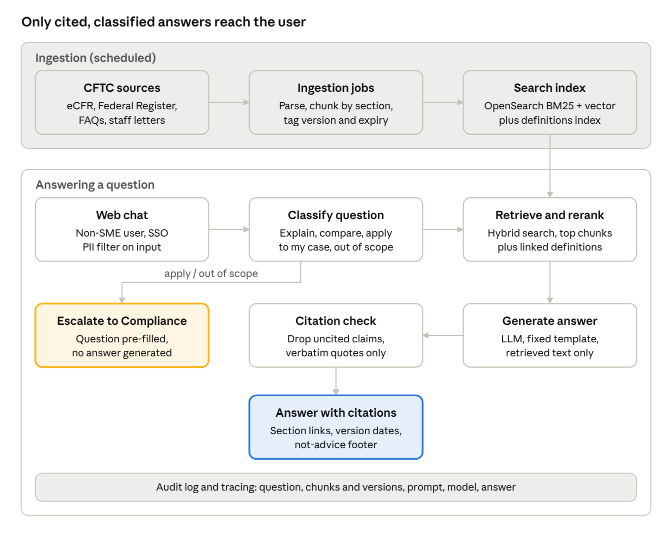
architecture · ingestion and query path
Interpretive and out-of-scope questions leave the flow at classification and go to Compliance; every step writes to the audit log.

Proposed tech stack
The stack favours hybrid search and boring, auditable components over agent frameworks. Users type section numbers ("45.3") and defined terms as often as plain questions, so keyword search matters as much as vectors. If the firm already has an approved internal LLM platform, it replaces the model and gateway rows below.
Layer | Proposed | Alternative | Why
LLM (answer generation) | Claude via AWS Bedrock, inside the firm's cloud account | GPT-4-class via Azure OpenAI | Strong at long, cited answers; data stays in the firm's tenancy
Classifier (question class) | Small fast model (e.g. Claude Haiku) with a few-shot prompt | Fine-tuned small classifier | Cheap, fast, runs on every question
Embeddings | Voyage or Cohere embed (via Bedrock) | OpenAI text-embedding-3-large | Good on legal and financial text
Search index | OpenSearch: BM25 + vector (hybrid) in one engine | Postgres + pgvector + full-text | Exact-match on citations and terms, plus semantic recall
Reranker | Cohere Rerank | bge-reranker, self-hosted | Biggest single lift in answer precision
Orchestration | Plain Python service (FastAPI), explicit pipeline steps | LangGraph | Every step logged and testable; fewer hidden prompts for model risk review
Ingestion | Python jobs on Airflow; eCFR and Federal Register APIs | AWS Step Functions | Scheduled, versioned, re-runnable loads
Document store | S3 (raw + parsed), Postgres (metadata, versions) |  | Point-in-time replay of any answer
Tracing and evaluation | Langfuse (self-hosted) + Ragas + a custom citation checker | LangSmith | Trace every answer; run the golden set on every change
Front end | React web chat with SSO (Entra ID / Okta) | Streamlit for the pilot only | Citation side panel, feedback buttons, escalate button
Channel (Phase 2) | Teams or Slack bot over the same API |  | Meet users where they ask questions today
Hosting | Containers on EKS or ECS in a private VPC | Firm's internal platform | No public endpoints; firm network controls

Evaluation and quality
No launch without a golden set of about 300 questions written and answered by SMEs, signed off by Compliance. Every change to prompts, models, chunking or corpus runs against it, and a drop below threshold on the held-out set blocks release.
Golden set mix
- About 200 explain questions across the 13 parts, with the expected citations.
- About 50 apply-to-my-case questions that must be escalated, not answered.
- About 30 out-of-scope questions (other regulators, general finance).
- About 20 trick questions: superseded rules, expired staff letters, conflicting sources.
Held-out split
The golden set is split 70/30, stratified by part and question class. The team tunes prompts, chunking and retrieval only on the 70% tuning set. Release gates use only the 30% held-out set, which SMEs refresh each quarter so it is never tuned against.
Retrieval comparison (before the stack is locked)
Set-up | Recall@5 | MRR | Keeps its place if
BM25 only |  |  | Baseline
Vector only |  |  | Beats BM25 on plain-language questions
Hybrid (BM25 + vector) |  |  | Beats both on the full held-out set
Hybrid + reranker |  |  | Lifts recall@5 by 3 points or more, within the latency budget
All four run on the held-out set with the same corpus snapshot; the winner is the stack that ships.
Metric | How measured | Release gate
Citation accuracy | Cited section actually supports the claim (SME-labelled, then LLM-judge checked against labels) | 95% or higher
Retrieval recall | Expected section in the top 5 results | 90% or higher
Escalation accuracy | Interpretive questions correctly escalated | 100% in UAT
Faithfulness | No claim beyond the retrieved text (Ragas faithfulness + citation checker) | 95% or higher
Readability | Non-SME panel rates the answer understandable | 4 out of 5 or higher
Latency | Time to full answer | Under 10 seconds at p95
In production, SMEs review a 5% weekly sample plus every answer with a thumbs-down.
Saved, reproducible results
Every evaluation run writes eval_runs/<run_id>/results.json, stored in S3 and kept alongside the release record:
- Manifest: corpus snapshot hash, index version, embedding model, prompt version, LLM and version, retrieval config, random seed.
- Per question: question id, split, expected citations, retrieved chunk ids with scores, answer, citations returned, each metric's score, pass or fail.
- Summary: each metric on the held-out set, and the change against the last release.
Any run can be replayed from its manifest, and the release pipeline diffs the new results file against the last approved one.

Governance and controls
Treat this as a model under the firm's model risk framework (in the US, SR 11-7 style validation) from day one; retrofitting it after the pilot costs months.
Area | Control | Owner
Model risk | Model inventory entry, validation of the golden-set results, annual revalidation, revalidation on any model change | Model Risk Management
Content ownership | Compliance approves corpus sources, the answer template and the escalation wording | Compliance
Audit trail | Store each question, retrieved chunks with versions, prompt version, model version and answer, for the retention period Compliance sets | Tech
Data protection | No client, trade or personal data in prompts; a filter blocks and warns on account numbers, LEIs tied to clients, names | Tech + InfoSec
Access | SSO, role-based access; Phase 2 internal policies visible only to entitled groups | Tech
Vendor and data residency | LLM and embedding calls stay inside the firm's cloud tenancy; no training on firm data | Procurement + InfoSec
Change control | Prompt, model and corpus changes go through release with a golden-set run attached | Tech
User disclosure | First-use acknowledgement that answers explain rule text and are not compliance advice | Compliance

Delivery plan
About 18 weeks to a validated pilot, with three gates that each need a named sign-off. Week counts are estimates to be firmed up once the build-on-internal-platform decision is made.
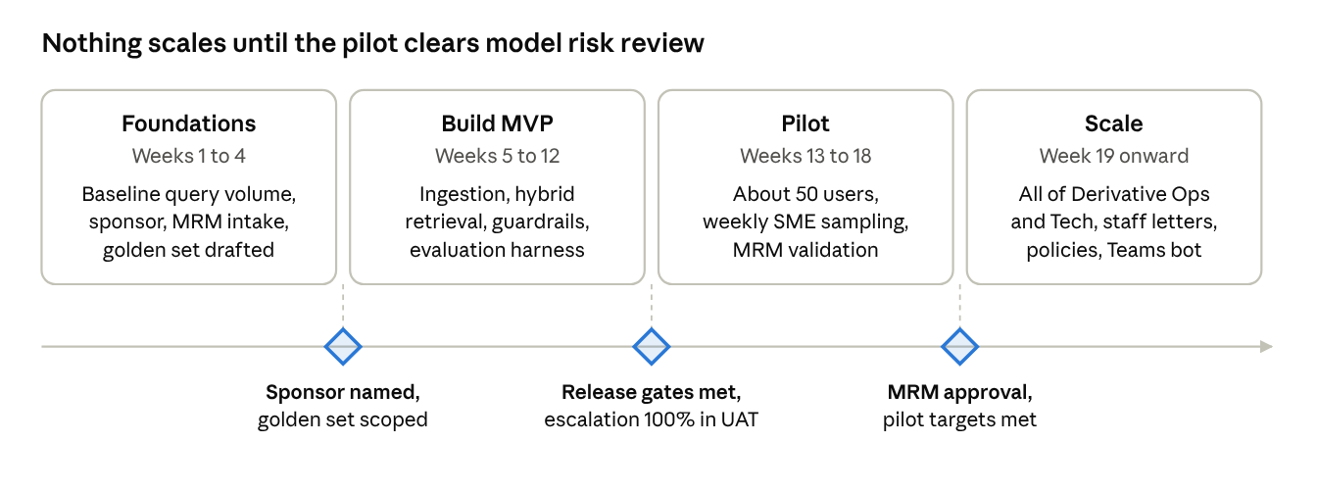
delivery roadmap · 4 phases, 3 gates
Role | Allocation | Phase
Product owner (Derivative Ops) | 0.5 FTE | All
ML / backend engineers | 2 FTE | Build onward
Data engineer (ingestion, versioning) | 1 FTE | Build onward
Front-end engineer | 0.5 FTE | Build and pilot
SMEs (Ops, Reg Reporting) for golden set and sampling | About 3 person-weeks, then 2 hours a week | Foundations onward
Compliance sponsor | Approvals at each gate | All
Model Risk Management | Intake, then validation | Foundations and pilot

Risks, assumptions and open decisions
Risk | Likelihood | Impact | Mitigation
Users treat answers as compliance advice | High | High | Question classifier, fixed footer, first-use acknowledgement, escalation button
Answer cites a superseded rule or expired relief | Medium | High | Versioned corpus, expiry metadata, daily eCFR diff, trick questions in the golden set
Compliance will not own the corpus or sign the golden set | Medium | High (blocks launch) | Secure a named Compliance sponsor before build starts
Model risk review takes longer than the build | High | Medium | Engage MRM in week 1; keep the pipeline explicit and documented
Low adoption because answers feel hedged | Medium | Medium | Plain-language summary first, caveats after; pilot with a group that has real volume
Licensing of third-party commentary | Low | Medium | Phase 1 uses public CFTC and government sources only
Assumptions
- The firm has, or will approve, an LLM provider running inside its own cloud tenancy.
- Public CFTC sources are enough for Phase 1; internal policies wait for Phase 2.
- SMEs can give about 3 person-weeks to write and answer the golden set.
Open decisions
- ☐ Build on the firm's internal AI platform, or a standalone stack as proposed?
- ☐ Which pilot group, and who is the Compliance sponsor?
- ☐ Is the scope CFTC only, or CFTC plus SEC security-based swaps from Phase 2?
- ☐ Retention period for question and answer logs.

